1. Probability Theory: Videos, etc.

This lecture supplies more detail on the fundamentals of probability.

Videos (in class)

Perdisco: "Probability"
http://www.youtube.com/watch?v=rhOTjLOPWbU

Khan Academy: "Addition Rule"
http://www.youtube.com/watch?v=QE2uR6Z-NcU

More material (home use)

Khan Academy: "Basic Probability"
http://www.youtube.com/watch?v=uzkc-qNVoOk

Slides: "Adding and multiplying probabilities"
http://www.stat.berkeley.edu/~bradluen/stat2/lecture16.pdf

2. Probability Theory: Venn Diagrams

We denote an event with a capital letter (A). The rectangle represents our universe of possible outcomes. The relative size of the circle corresponds to the magnitude of the probability of A occurring, or P(A).

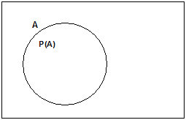

Mutually exclusive events. Represented by two non-overlapping circles.

Example: A is "rolling a 1 or a 2 on a fair die", and B is "rolling a 6 on a fair die." P(A) = 2/6 = 1/3. P(B) = 1/6.

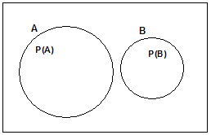

Addition rule for mutually exclusive events: P(A or B) = P(A) + P(B)

The probability of either A or B (or both) occurring is indicated by the combined area of circles A and B. For mutually exclusive events, the circles do not overlap. The combined area is therefore simply the sum of the individual areas.

Example: using same die roll example, the probability A (rolling a 1 or a 2) or B (rolling a 6) = P(A) + P(B) = 2/6 + 1/6 = 3/6 = 1/2.

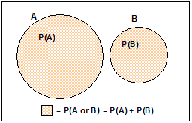

Non-mutually exclusive events are represented by overlapping circles. The overlapping region corresponds to the joint occurrence A and B.

The probability of A or B is still indicated by the total shaded area. However if we were to simply add P(A) and P(B), we would count the overlapping area twice. The addition rule for non-mutually exclusive events is therefore

P(A or B) = P(A) + P(B) – P(A and B)

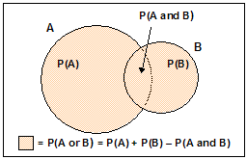

Conditional Probability

The conditional probability of B given A, or P(B|A), is the probability that B will occur, given that A occurs.

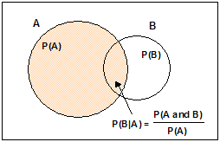

If A and B are mutually exclusive, P(B|A) = 0.

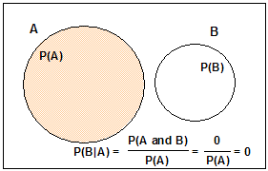
When A occurs (shaded circle), B never occurs

P(B|A) can be greater than P(B), or less than P(B):

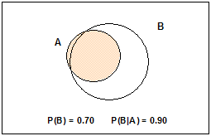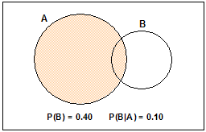
90% of A falls within B 10% of A falls within B
Given A, B almost always occurs Given A, B rarely occurs

Finally, P(B|A) can be 1.0:

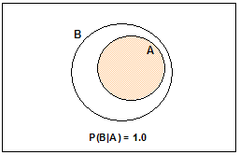
If A occurs (shaded region), B always occurs

